Game Planning: Four Corners
Main Menu
Lives
0 Feathers
10:00
Feather amount
Player
Timer
Game Screen (draw an image of your game)

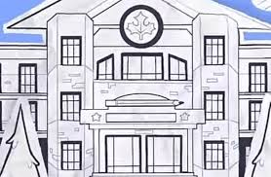

Project Design
Player Experience:
Prediction, collecting how many amount

Core Mechanic:
Collect as many feathers as you can

Core Game Loop: collect feathers without dying.
Game Flow and Screens Overview (flowchart)

Game Theme (including Story and Setting)

The game takes place in fundamental paper education school where Engel has lost his feathers that he collected, so he asks one of his friends to help him to collect the feathers for him. But there’s some danger while collecting some feathers.

